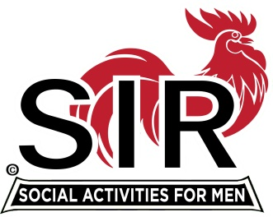
Las Trampas Branch 116
BEC Meeting Agenda
March 15, 2021, 8:30 AM
The Mission of SIR is to enhance the lives of our members through fun activities, events and luncheons – while making friends for life.

8:30 am Call to order; Secretary confirm a quorum

8:35 Secretary –Paul Ramacciotti – Approval of February 15, 2021 and February 22 Special Meeting minutes

8:40 Treasurer –/Alan Fitzgerald – Report

8:45 Standing Reports
- Membership – Phil Goff
- RAMP Department Head Reports:
- Recruitment
- Activity Coordinator
- Member relations
- Publicity

9:00 Big SIR Report – Sam Beret

- March 15 monthly meeting agenda
- State SIR Covid Survey
- Bocce Ball and Golf Lessons Activity Chair changes

9:15 Little SIR Report - Fred Wachowicz
1. Speaker:
2. Birthday Boys
3. Diversity Team Report

9:25 Virtual Lunch Zoom Process - Neil Schmidt

9:30 Old Business
- TBA
New Business:
- Approve Branch outdoor activities subject to: 1- Health Directives from CA and Contra Costa County, 2- State SIR Directives, 3- Branch Activity Protocol
Fishing
Bocce Ball
Walking Tours
Pickle Ball
Amiable Amblers

2- Approve Activity Protocols for the above five activities

Resolution recommended by State SIR

SIR Outdoor Activities
Branch BEC Resolution

RESOLVED, that all SIR sponsored (name of activity) are henceforth approved by SIR Branch (branch #) provided: (Branch number)
- such activities are not prohibited by an applicable order of the California Department of Public Health or County or Municipal Health Department, and
- all activities are conducted under written protocols in a strict compliance with all applicable State and Locally mandated mask, hand sanitizing, distancing requirements, and any other pertinent Health Related Requirements.
The Resolution and the written protocols must be passed by the Branch BEC and recorded in the Branch minutes.
**************************************

9:45 Adjourn; Next BEC Meeting, April 19, 2021

Join Zoom Meeting Weblink
https://us02web.zoom.us/j/85332344422
Meeting ID: 853 3234 4422
Passcode: 612956
Dial by home phone: (669) 900-9128

